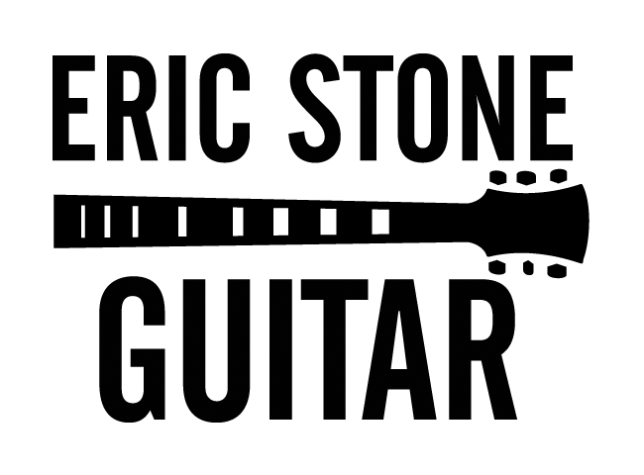
www.ericstoneguitar.com * eric@ericstoneguitar.com * (720) 515-1178
How to Write Your Own Licks so You Can Find Your Own Voice on the Guitar – Carl Verheyen’s Approach
One of the most memorable and important experiences I had during my time as a student at the Los Angeles Music Academy College of Music (LAMA) was being able to take a ten week master class from virtuoso electric guitar player Carl Verheyen. While you might not know Carl’s name, you have undoubtedly heard him play before. He has been one of the most prolific session guitar players in Los Angeles over the last few decades and his work can be heard on many blockbuster films and popular television shows. Carl is also a member of the band Supertramp and he’s an accomplished solo artist. Carl is among the most talented, jaw-dropping, and unique contemporary guitar players in the world. He has developed a style that’s uniquely his own. Although his primary areas of focus are rock and blues, he can play any contemporary style and his ideas can be translated to any style.
During the class, Carl spent some time telling us how he was able to develop his playing style – mainly through creating lick books. He went into great detail discussing his process for writing licks and how he incorporates it into his practice time. In this article, I am going to share Carl’s approach to lick books and how you can use licks to develop your own voice. This information comes directly from the notes I took during his class.
Before you read on, I highly recommend that you take some time and check out Carl’s videos on YouTube. You’ll find that his playing is highly unpredictable and that he uses a lot of unorthodox intervallic leaps in his solos. All of this is a result of years of writing his own licks and using systematic practice to seamlessly integrate the new ideas into his playing.
Writing Licks – The Mechanics of How Carl Does It
Carl began writing his own licks in 1978. He writes everything on manuscript paper and keeps every lick he’s ever written in dozens of lick books or diaries in his practice space. Carl’s approach is so organized that he can literally go back and look up exactly what he was doing on any particular day in the mid 80’s.
Carl writes his licks in standard musical notation. He’ll write out a line of musical notes. Above the notes, he’ll put a number indicating the position he’s playing in and if he changes positions. For example if Carl starts in the 5th position and plays the first four notes there before shifting to the 7th position, he’ll put the number 5 above the first note, nothing above the next three notes, then put the number 7 above the next note and so on. Below every single note he writes, Carl will put which finger he uses.
Carl’s goal is to be able to look back over licks he wrote years ago and be able to immediately know exactly how to play it and what he was thinking while he wrote it. That’s why he includes so much information about the fingers he uses and the position he’s playing his licks in. You just can’t get that kind of information from tablature.
My notes don’t indicate how many licks Carl wrote per day although I seem to remember that he wrote three daily. Regardless, Carl has written his own licks every day for decades. Try to do the math of writing three original licks per day since 1978! It’s no wonder he’s been able to create such a unique style.
Writing Licks – Carl’s Approach to Creating New Ideas
Carl has three main ways that he creates new licks – all with the goal developing his own voice and style on the guitar.
- Writing original ideas. There are a few ways Carl approaches coming up with something new. First, he’ll put on a backing track and start playing over it. If sounds like something he’s done before, he won’t put it in his book. Once he feels like he’s starting to play something that’s different and feels inspiring, he’ll stop the backing track, and write down the lick. Carl will also approach this idea in another way. Perhaps he’s recently been listening to one of his influences. For example, if he’s been on a Jimi Hendrix kick, he’ll sit down and start emulating Hendrix’s style. Carl will then adapt Hendrix’s style to his own playing and once he feels like his original voice is coming out, he’ll then add those ideas to his lick book. Carl is careful not to add anything to the book that sounds like one of his influences. Carl will also occasionally take standard blues and rock licks and make them his own.
- Blank page. This method is a big part of how Carl developed his signature intervallic style. For example, Carl will say to himself that he wants to write a lick that starts on F# on the low E string and finishes on the E on the 12th fret of the high E string. He’ll decide on a key center and then give himself the task of creating a new and interesting line based on his pre-determined parameters. With this idea, Carl may also start high on the neck and finish low on the neck. Carl puts a lot of thought into his note choices and will only add something to his lick book that reaches his high standards. No matter what approach he uses, Carl will not add normal and pedestrian licks to his book!
- Freshen up old ideas. When creating licks, Carl also keeps his recent and older lick books handy. He’ll go back to old material, review it, change either the notes he’s playing or the chord he’s playing over, and then add it to his new licks. He might go back a few weeks, months, years, or even decades and do this!
When writing licks, Carl focuses his attention on tonal centers. He’ll write lines based mainly on major, minor, dominant, and diminished chords. Carl will occasionally take a major lick and make a dominant version of that lick and so on. He will also put in chord progressions, chord ideas, and song ideas to his lick book.
From what I recall, Carl does not necessarily concern himself with fitting his ideas into a pre-determined number of measures nor does he vary the rhythms he uses as everything is strictly quarter notes. However, you can certainly explore those aspects as you develop your own lick book.
Carl will also experiment in his writing and his improvising by playing his licks in different keys.
Implementing New Licks in Your Playing – Carl’s Approach
Once Carl creates new licks, he systematically incorporates and integrates them into his playing. Carl will put on a backing track and isolate each individual lick. He’ll figure out ways to play them so that he seamlessly plays into each lick and out of each lick without it sounding forced. He will then work on improvising with all of the licks he’s working on.
Using Carl’s Methods in Your Playing
I hope you can see just how powerful these ideas can potentially be for your improvising. I recommend starting with Carl’s approach and adapting it to fit your needs and preferences.
Perhaps you’re working on jazz and you want some new ii-V-I lines. You can take whatever jazz concept you’re learning, create your own lines and licks, and play them over backing tracks and insert them into whatever tunes you’re working on. You can do the same thing for any style you’re working on.
I also want to mention that most of us aren’t at the level that Carl is where we can disregard anything that sounds like our influences. Learning to play like your influences can still be a huge part of your lick book and your overall development. What you could do is take a line by someone you admire. You can figure out what they’re doing, and then change it so it becomes something that’s unique to you. Or you can play their line but figure out some of your own ideas that will lead into their line and out of their line.
As you can see, the possibilities for coming up with your own licks and creating your own voice on the guitar are endless!
Final Thoughts
At least two of my other teachers over the years were able to get fantastic results on the guitar from writing their own licks and developing their own voice. Chris Napoli was my first guitar teacher and he currently owns and operates successful music schools in the Philadelphia area. Chris kept lick books both to develop his own playing and as a teaching tool. Chris ultimately focused on running his business but even after all these years, I still consider him to be among the best guitarists I’ve ever seen and studied with. Also, I studied improvisation with Art Renshaw at LAMA. Art wrote his own licks for many years as he developed his improvising style. He has a unique approach to superimposing triads and arpeggios. Chris and Art both spent a tremendous amount of time applying their licks to their own playing and improvisations. While they didn’t have as systematic and as thorough of an approach as Carl, they were still able to reach extremely high levels of playing through writing licks.

